**Django-ERP User Manual**

**Inventory Management**

## 1. Real-time inventory

### 1.1 Business Introduction

Real-time inventory is used to view the company's real-time inventory status, which can reflect the company's inventory capital distribution and provide data support for reducing inventory capital.

### 1.2 Interface Description

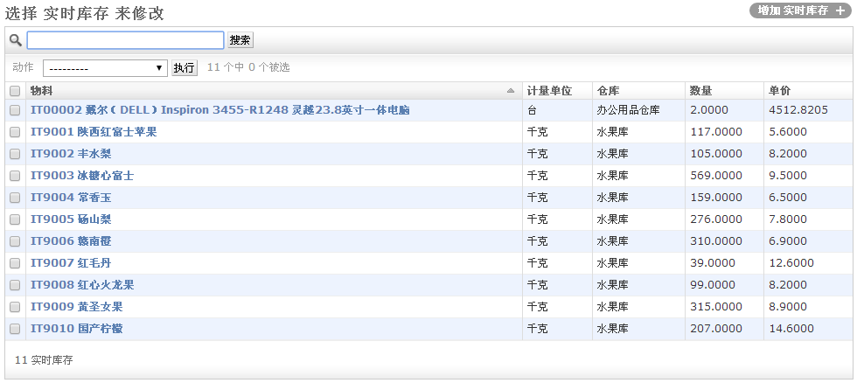

【Material】: From the material library, when there is initial data import or purchase into the warehouse, the material enters the inventory management

[Unit of measurement]: The unit of measurement of the material, obtained when entering the warehouse

[Warehouse]: the warehouse where the materials are stored; [Quantity]: the inventory quantity; [Unit Price]: the purchase price excluding tax;

### 1.3 Operation Instructions

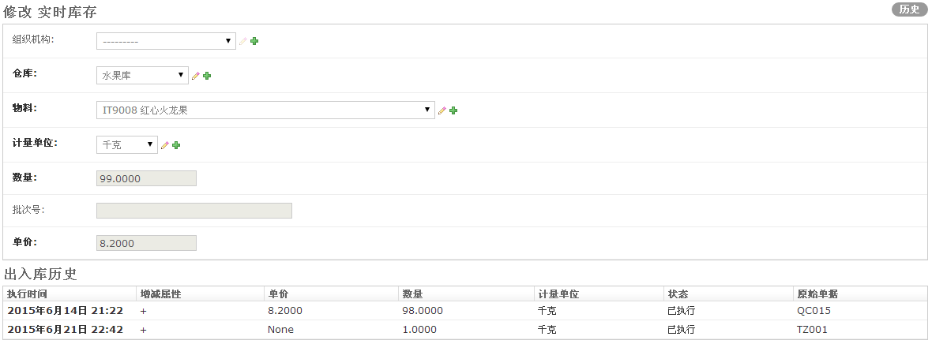

Click an entry to view the historical in and out information of this material, which is convenient for checking historical accounts;

## Second material picking list

### 2.1 Business Introduction

The material requisition is the basis for the delivery of materials and the basis for project cost accounting. When calculating the material cost of a project, the material cost is calculated based on the delivery amount of the material requisition.

### 2.2 Interface Description

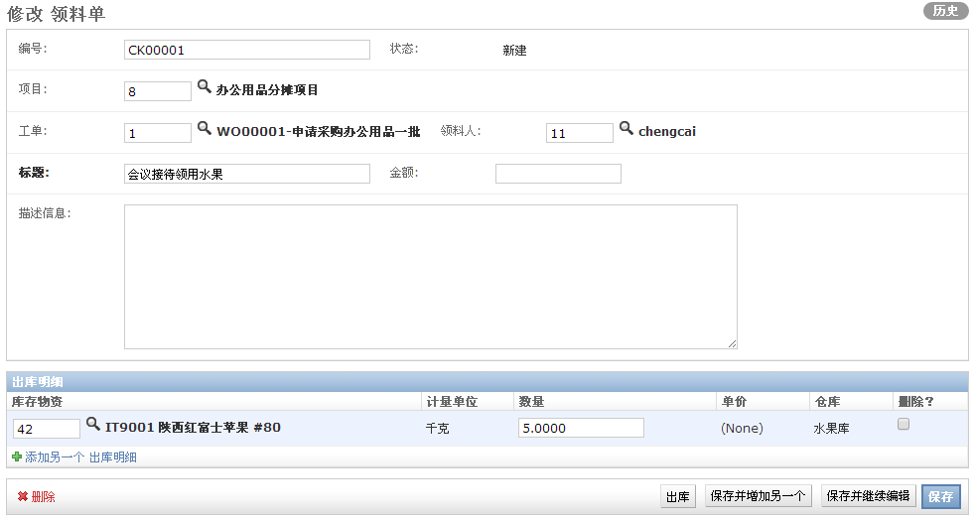

* **Material picking list master document**

[Number]: Automatically generated serial number for retrieval

【Status】: Automatically updated according to process status

【Project】: Please select the project that will bear the cost of this material collection

[Work Order]: If you want to pick materials by work order, please select the work order

【Receiver】: Default is the current user

【Title】: Please enter a brief description of this pick

[Amount]: Automatically calculated when leaving the warehouse, please do not fill in manually

【Description information】: Detailed description of this material collection

* **Material picking list**

[Inventory Materials]: Select the materials you want to collect from the inventory

【Unit of measurement】: Click the 【Save and continue editing】button to automatically display the

【Quantity】: Fill in the quantity of materials to be collected

[Unit Price]: Automatically filled in after clicking the [Shipment] button

【Warehouse】: Click the 【Save and Continue Editing】button to automatically bring out

### 2.3 Operation Instructions

* **Non-warehouse personnel operation**

Step 1: Fill out the form

After filling in the master document and detail document according to the interface requirements, click the [Save and Continue Editing] button

Step 2: Submit documents

If the [Material Picking List] is configured with a workflow, please click the [Submit] button to submit for approval;

* **Warehouse staff operation**

Step 1: Click the [Out of Stock] button to carry out the material out of the warehouse



After clicking the [Out of Stock] button, the following confirmation interface appears

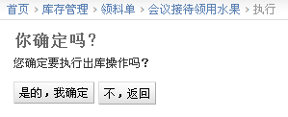

Click the [Yes, I am sure] button to complete the outbound operation

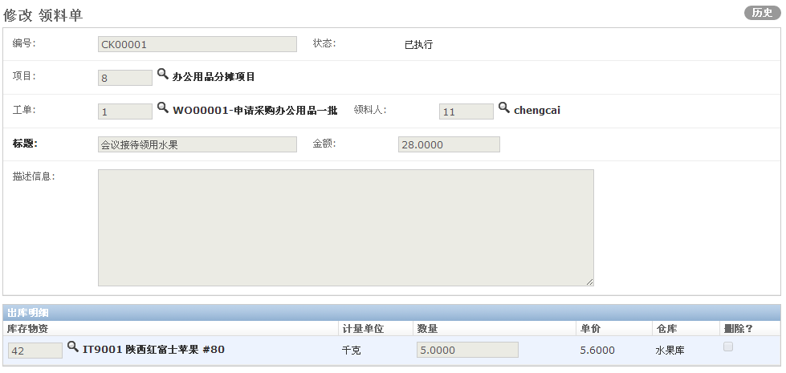

## Three warehouse orders

### 3.1 Business Introduction

The warehouse entry document is the follow-up operation of the purchase order, and the warehouse entry document must select the purchase order warehouse entry.

### 3.2 Interface Description

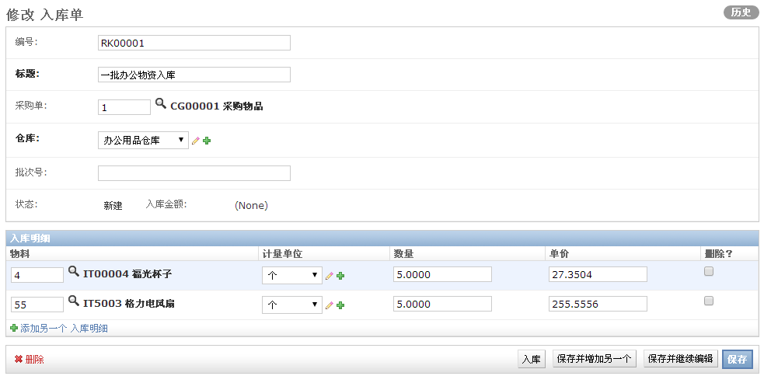

* **Inbound document master**

【Number】: Automatically generated based on the serial number

【Title】: Enter a brief description of this incoming order

【Purchase Order】: Please select the purchase order to be put into storage

【Warehouse】: Please select the warehouse for storage

【Batch number】: You can enter the batch number

【Status】: Automatically updated according to the status of the process

[Warehouse Amount]: The default value is empty. After clicking the [Warehouse] button and confirming, the warehouse amount will be automatically calculated.

* **Incoming order details**

[Material]: After entering the master document data, click the [Save and Continue] button to automatically load this data

[Unit of Measure]: After entering the master document data, click the [Save and Continue] button to automatically load this data.

[ Quantity ]: After entering the master document data, click the [Save and Continue] button to automatically load this data

[Unit Price]: After entering the master document data, click the [Save and Continue] button to automatically load this data

### 3.3 Operation Instructions

* **Step 1: Enter the master document**

Select the purchase order, enter the title, and click the [Save and Continue] button. The system will automatically load the purchase order details.

* **Step 2: Enter the warehousing operation**

After the master document is saved, the warehouse keeper can click the [Enter Warehouse] button to perform inventory entry operations. After clicking, the following interface will appear:

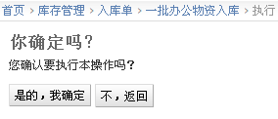

Click the [Yes, I am sure] button to confirm the operation. The entry order after the entry operation is as follows:

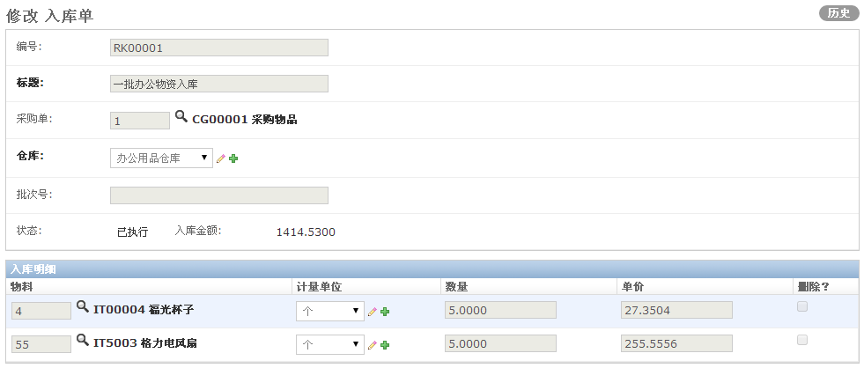

## 4. Inventory Adjustment

### 4.1 Business Introduction

Inventory adjustment is used to adjust the quantity of materials in the warehouse, increase or decrease the quantity. Inventory adjustment does not change the unit price of inventory materials.

### 4.2 Interface Description

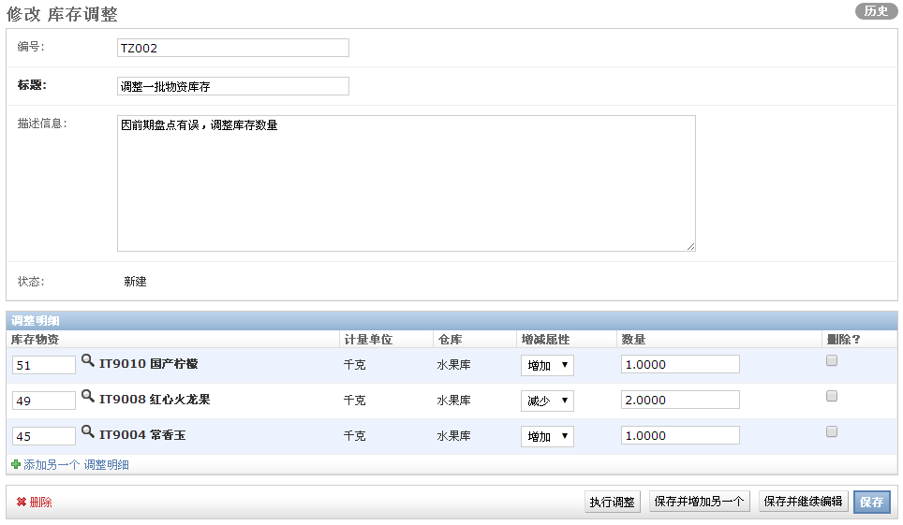

* **Inventory Adjustment Master Document**

[Number]: Automatically generated by serial number, used for retrieval

【Title】: Please enter a brief description of the inventory adjustment

【Description】: You can enter a detailed description

[Status]: The default is new, and it will be automatically updated according to the process

* **Inventory adjustment detail document:**

【Inventory materials】: Please select inventory materials

【Unit of measurement】: Automatically bring out

【Warehouse】: Automatically take out

[Increase or decrease attributes]: Please select [Increase] or [Decrease]

【Quantity】: Please enter a positive number

### 4.3 Operation Instructions

* **Step 1: Enter the document information**

After entering the master document and detailed document, click the [Save and Continue] button to save the document first.

* **Step 2: Perform adjustments**

After the document is saved, the warehouse manager can click the [Execute Adjustment] button, and the following interface will appear:

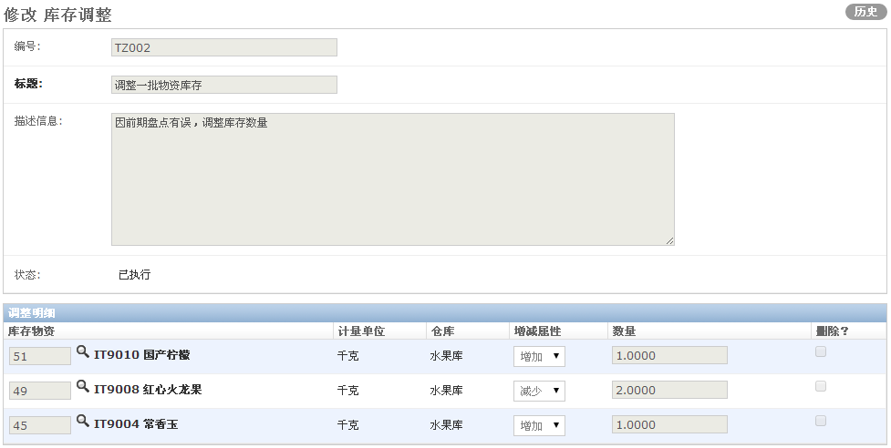

## Five return orders

### 5.1 Business Introduction

A return order is used to return materials that have been received, such as leftover materials or borrowed tools.

### 5.2 Interface Description

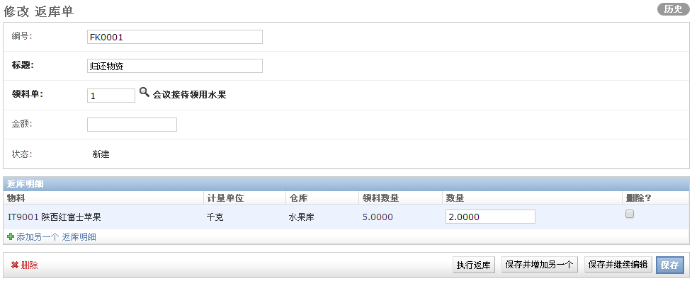

* **Return order master document**

[Number]: Automatically generated by serial number, used for retrieval

【Title】: Please enter a brief description of the return order

【Material Picking Form】: Please select the corresponding material picking form

【Amount】: Default is empty, automatically updated after execution

【Status】: Automatically updated according to process status

* **Return order details**

【Material】: Automatically brought out from the purchase order

【Unit of measurement】: Automatically brought out from the purchase order

【 Warehouse 】: Automatically brought out by purchase order

[Material Quantity]: Automatically taken from the purchase order

【Quantity】: Please enter the quantity to be returned

### 5.3 Operation Instructions

* **Step 1: Enter the master document**

Select the material requisition, enter the title, and click the [Save and Continue] button. The system will automatically load the material requisition details.

* **Step 2: Enter the warehousing operation**

After the master document is saved, the warehouse keeper can click the [Execute Return to Warehouse] button to perform the inventory entry operation. After clicking, the following interface will appear:

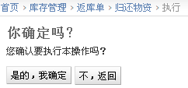

After clicking the [Yes, I'm sure] button, the interface is updated as shown below

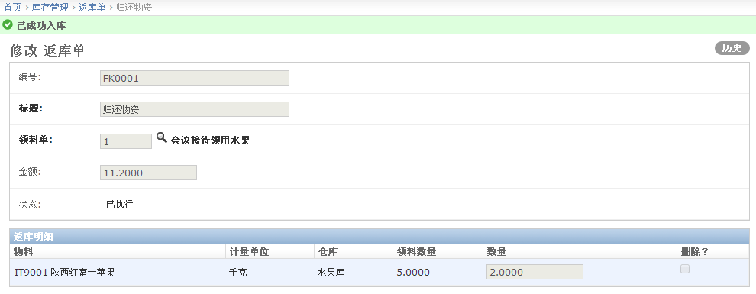

## Beginning inventory of the sixth period

### 6.1 Business Introduction

Initial inventory import is used to quickly import original inventory materials and inventory quantity information when the system is initialized.

### 6.2 Interface Description

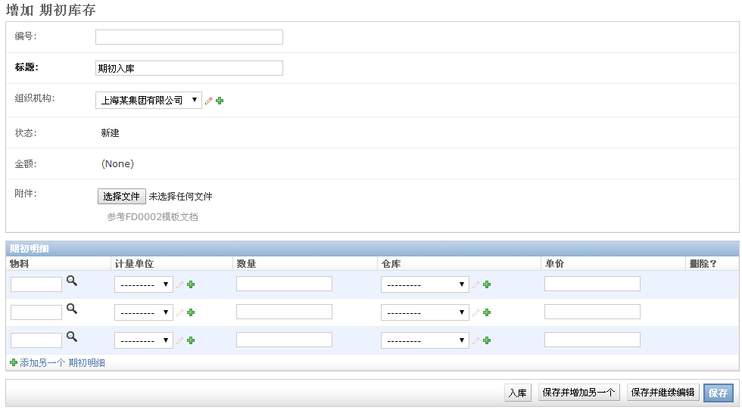

* **Opening inventory master document**

[Number]: Automatically generated by serial number for retrieval

【Title】: Enter a brief description

【Organization】: Select an organization

[Status]: The default is New, which will be automatically updated according to the process status

[Amount]: Default is empty, and will be automatically updated after [Entry] is executed

【Attachment】: Please refer to 【FD0002】 and upload the document after entering the data

* **Opening inventory detail document**

【Material】: Automatically obtain from attachments

【Unit of measurement】: Automatically obtained from the attachment

【Quantity】: Automatically obtained from the attachment

【Warehouse】: Automatically obtain from attachments

【Unit Price】: Automatically obtained from the attachment

### 6.3 Operating Instructions

* **Step 1: Enter the master document**

After entering the title and selecting the attachment, click the [Save and Continue] button and the system will automatically load the template details.

* **Step 2: Enter the warehousing operation**

After the master document is saved, the warehouse keeper can click the [Enter Warehouse] button to perform inventory entry operations. After clicking, the following interface will appear:

